**Lyme Disease Frequently Asked Questions**

***Written by: Saadeh Ewaidah, MD, MPH, FACE***

**What is Lyme disease?**

Lyme disease is a tickborne disease caused by bacteria called *Borrelia burgdorferi*, and rarely, *Borrelia mayonii.*

**Where can people get Lyme disease?**

People get Lyme disease from ticks that carry the bacteria. About 10–50% of blacklegged ticks carry the bacteria in high-risk areas, which include:

* Eastern states, primarily New England and the mid-Atlantic
* Upper Midwestern states, especially Wisconsin and Minnesota
* The West Coast, particularly parts of northern California and, less commonly, Oregon and Washington

**How is Lyme disease transmitted to humans?**

Lyme disease is transmitted to humans through the bites of infected blacklegged ticks (*Ixodes scapularis* in the northeastern or central United States or *Ixodes pacificus* in the western United States, Figure 1). In most cases, a tick must be attached for at least 24 hours to transmit Lyme disease. Most people are infected through the bites of immature ticks called nymphs. Nymphs are tiny (less than 2 mm) and difficult to see. They most commonly bite during spring and summer.

Adult ticks, which most commonly bite during the fall, can also transmit Lyme disease bacteria. They are more likely to be found and removed because they are bigger than nymphs.

Figure 1. Relative sizes of blacklegged ticks at different life stages.

**How many stages of Lyme disease are there?**

Lyme disease has three stages:

1. Localized Erythema Migrans. The disease could disseminate if misdiagnosed or not treated appropriately with antibiotics.
2. Early dissemination of infection.
3. Late dissemination of infection.

**What is** **Erythema Migrans and how long does it take to appear on the skin?**

Erythema Migrans (EM) occurs in 70-80% of infected people and typically, but not always, appears like a bull’s eye or target appearance (Figure 2). EM can appear 3 to 30 days after a bite of an infected tick (average 7 days). It is localized and expands up to 12” inches or more in diameter. Most EMs are > 5cm (approximately 2”). EM may be accompanied by flu-like symptoms (fever, headache, tiredness, swollen lymph nodes, and joint and muscle pain).

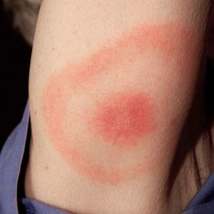

Figure 2. <https://www.pcds.org.uk/clinical-guidance/lyme-disease>

**What clinical manifestations should providers look for in Stage 2 of Lyme disease?**

In stage 2 (or early dissemination infection stage) the disease progresses weeks after the initial tick bite and may include dermatologic, neurologic or cardiac manifestations.

* Dermatologic Manifestations:
  + Multiple EM rashes, distant from site of tick bite (Figure 3).
* Neurologic Manifestations:
  + Cranial neuritis, most commonly Bell’s palsy (facial paralysis, can be bilateral), (Figure 4).
  + Lymphocytic meningitis
  + Painful radiculoneuritis involving one or multiple dermatomes.
  + Painful peripheral motor and sensory neuropathy (mononeuritis multiplex)
  + Intracranial hypertension (rare).
* Cardiac Manifestations:
  + Lyme carditis resulting in conduction abnormalities (e.g., second-degree, and third-degree heart blocks)
  + 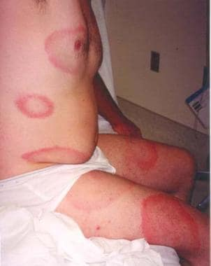Rarely myopericarditis can be fatal.

Figure 3: [Multiple EM rashes](https://emedicine.medscape.com/article/330178-clinical?form=fpf) Figure 4. [Bell's palsy Disease Reference Guide](https://www.mayoclinic.org/diseases-conditions/bells-palsy/symptoms-causes/syc-20370028)

**What clinical manifestations should providers look for in Stage 3 of Lyme disease?**

Stage 3 (late dissemination infection stage) usually occurs months after a tick bite and is commonly associated with:

* Rheumatologic Manifestations:
  + Oligoarticular arthritis: transient, migratory arthritis and effusion in one or multiple joints, often large joints; may cause [Baker’s cyst](https://orthoinfo.aaos.org/en/diseases--conditions/bakers-cyst-popliteal-cyst/) (Figure 5).
  + Migratory pain in tendons, bursae, muscle, and bones.

Figure 5. <https://orthoinfo.aaos.org/en/diseases--conditions/bakers-cyst-popliteal-cyst/>

**When should providers consider testing for Lyme disease?**

To consider testing for Lyme disease, providers should consider a patient’s potential exposure to infected blacklegged ticks, whether the patient’s signs and symptoms are clinically consistent with Lyme disease, and the possibility that other illnesses may cause similar symptoms.

**Which diagnostic test can providers order for Lyme disease?**

No single test for Lyme disease is sensitive and specific enough to diagnose Lyme disease, so CDC currently recommends a [two-step testing process](https://www.aphl.org/aboutAPHL/publications/Documents/ID-2024-Lyme-Disease-Serologic-Testing-Reporting.pdf). Both steps are required and can be performed on the same blood sample. Serologic testing should use validated first- and second-tier tests (Figure 6):

* Standard two-tier test (**STTT**): An initial (first tier) enzyme immunoassay (**EIA**) or immunofluorescent assay (**IFA**) followed by a second Immunoglobulin M (IgM) or Immunoglobulin G (IgG) western immunoblot (**WB**).
* Modified two-tier test (MTTT): An initial (first tier) enzyme immunoassay (**EIA**) or immunofluorescent assay (**IFA**) test followed by a second IgM or IgG enzyme immunoassay (**EIA**).

If the first step in either the STTT or the MTTT is negative, no further testing is recommended. If the first step is positive or equivocal/indeterminate, the second step should be performed. **The overall result is positive only when the first test is positive or equivocal and the second test is positive.** See details on test result interpretation below.

In 2019, FDA cleared several new Lyme disease serologic assays; using a testing method where a second test that is an EIA rather than a WB is now acceptable to diagnose Lyme disease.

Figure 6. Standard 2-tier and modified 2-tier algorithms for serodiagnosis of Lyme disease. The US Centers for Disease Control and Prevention recommended a standard 2-tier algorithm (A) and the modified 2-tier algorithm (B).

*For patients with signs or symptoms consistent with Lyme disease for less than 30 days, the provider may treat and follow up with a convalescent- phase serum sample. Patients with erythema migrans should receive treatment of the bases of clinical diagnosis. WB: Western blot. (2)

**How do I interpret STTT results?**

* If the first-tier test is negative, no further testing is indicated and there is no laboratory evidence of Lyme disease. Providers should note that negative results may occur in recently infected patients (i.e. </= 14 days) and if Lyme disease is suspected, then repeat testing in 7-14 days is recommended.
* If the first-tier test is total Ig immunoassay and is positive/equivocal and the second tier:
  + IgM and IgG immunoassays are both negative, there is no laboratory evidence of Lyme disease. Providers should note that negative results may occur in recently infected patients (i.e. </= 14 days) and if Lyme disease is suspected, then repeat testing in 7-14 days is recommended.
  + IgM is positive and IgG is negative, results are consistent with acute or recent Lyme disease infection *if the patient is presenting with symptoms within 30 days of symptom onset*. Testing in 7-14 days to confirm IgG seroconversion may be considered.
  + IgG is positive and IgM is negative, results are consistent with recent or past infection. Providers should note that IgG antibodies can be detectable for months to years after infection. No further testing should be performed.
  + IgM and IgG are positive, results are consistent with recent or past infection. Providers should note that antibodies can be detectable for months to years after infection. No further testing should be performed.

**How do I interpret MTTT results?**

The MTTT differs from the STTT in that the second-tier assay(s) are immunoassays, not immunoblots. Importantly, the immunoassays used as part of an MTTT must have received FDA clearance for the combination of assays and the tier in which they are used. MTTT assays are based on multiple, different *B. burgdorferi* antigens; assays used in pairs necessarily detect different antigens.

* If the first-tier test is negative, no further testing is indicated and there is no laboratory evidence of Lyme disease. Providers should note that negative results may occur in recently infected patients (i.e. </= 14 days) and if Lyme disease is suspected, then repeat testing in 7-14 days is recommended.
* If the first-tier test is total Ig immunoassay and is positive/equivocal and the second tier:
  + Immunoassay is positive for IgG but negative IgM, results are consistent with *B. burgdorferi* infection (Lyme disease) in recent or remote past. IgG-class antibodies may remain detectable for months to years following resolution of infection.
  + Immunoassay positive for IgM and IgG, results consistent with *B. burgdorferi* infection (Lyme disease) in recent or remote past.
  + Immunoassay is positive for IgM but negative IgG, results consistent with acute or recent infectious of *B. burgdorferi* (Lyme disease).
    - In untreated patients who have been sick for more than 30 days, positive IgM results should be interpreted with caution if IgG results are negative. Consider testing a new specimen collected in 7–14 days to demonstrate seroconversion.
  + If both tiers are equivocal consider repeat testing in 7–14 days if clinically warranted.

Although MTTT is recommended to be performed in sequence, some approved platforms can perform both tests concurrently.

* + Timing of infection (acute/recent vs. past) cannot be determined by these assays. Clinical correlation is required.
  + Results should not be used to monitor or establish adequate response to therapy. Response to therapy is confirmed through resolution of clinical symptoms; additional laboratory testing should not be performed.

**Are other diagnostic testing methods available?**

Other diagnostic methods are available; however, the bacteria that cause Lyme disease are only transiently present in the bloodstream, making culture and PCR less sensitive. Therefore, most diagnostic tests for Lyme disease rely on a patient’s antibody response. Additional testing methods include:

* Nucleic acid amplification test (NAAT) for *B. burgdorferi* or *B. mayonii*.
* Immunohistochemical assay (IHC) for detection of *B. burgdorferi* group-specific antigens.
* Isolation of *B. burgdorferi* or *B. mayonii* in culture.

**What exposure and the travel history information should the clinician collect?**

If a tick-borne disease is suspected, the clinician should ask the following:

1. Did the patient travel within the three months prior to symptom onset?
   * If yes, obtain location (i.e., within Illinois, within the US – specified state, or outside of the US) and departure and return dates.
2. Did the patient enter a tick habitat (wooded or brushy areas with leaf litter or areas with tall grass)?
   * If yes, obtain location of tick habitat and dates the patient entered the tick habitat.
3. Does the patient have a recent history of a tick bite within the three months prior to symptom onset date?
   * If yes, obtain date of tick bite and location at time of tick bite.

If any of the above questions are answered no, the clinician should also document that in the medical record.

**How is Lyme disease treated?**

* The Infectious Diseases Society of America, American Academy of Neurology and American College of Rheumatology have published [guidelines for the prevention, diagnosis, and treatment of Lyme disease](https://pubmed.ncbi.nlm.nih.gov/33257476/).
* [Antimicrobial prophylaxis for the prevention of Lyme disease following a tick bite might be beneficial in certain circumstances.](https://www.cdc.gov/lyme/resources/pdfs/lyme-pep-low-ink-p.pdf)
* In the early infection, appropriate oral antibiotic treatment may include Doxycycline, Amoxicillin, or cefuroxime axetil for 10–14 days depending on the patient’s age, medical history, pregnancy status or allergies. ([Treatment of Lyme Disease | CDC](https://www.cdc.gov/lyme/treatment/index.html)).
* For some individuals with neurologic Lyme disease, Lyme carditis, or Lyme arthritis, intravenous antibiotics treatment, typically with ceftriaxone, may be necessary.

**How can we prevent tick bites?**

Steps to prevent Lyme disease include using insect repellent, checking the body after being outdoors (Figure 7), removing ticks promptly, applying pesticides, and reducing time spent in tick habitat.

Figure 7. [Preventing Lyme disease by checking the body after being outdoors. (CDC)](https://www.cdc.gov/lyme/media/pdfs/Lyme-Disease-What-you-need-to-know.pdf)

**How can the provider remove the tick?**

Figure 8. [Removing tick](https://www.cdc.gov/ticks/pdfs/FS_TickBite-508.pdf)

Remove the tick as soon as possible:

1.Use fine-tipped tweezers to grasp the tick as close to the skin as you can.  
2. Pull upward with steady, even pressure. Don’t twist or jerk the tick.  
3. After removing the tick, clean the bite area and your hands with rubbing alcohol or soap and water.  
4. Dispose of the tick by flushing it down the toilet. If you would like to bring the tick to your healthcare provider for identification, put it in rubbing alcohol or place it in a sealed bag/container

**What is STARI?**

Southern Tick-Associated Rash Illness (STARI) is a Lyme-like illness that is a result of a bite from a lone star tick, *Amyblyomma americanum.* The adult female is distinguished by a white dot or "lone star" on her back (figure 9). Lone star ticks can be found from central Texas and Oklahoma eastward across the southern states and along the Atlantic coast as far north as Maine (Figure 10).

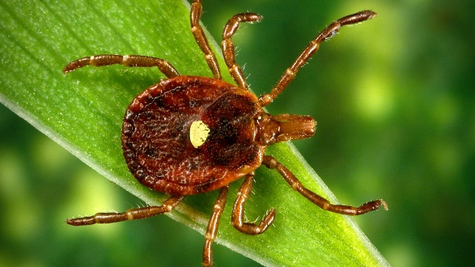

Figure 9. <https://www.cdc.gov/lyme/about/about-southern-tick-associated-rash-illness.html>

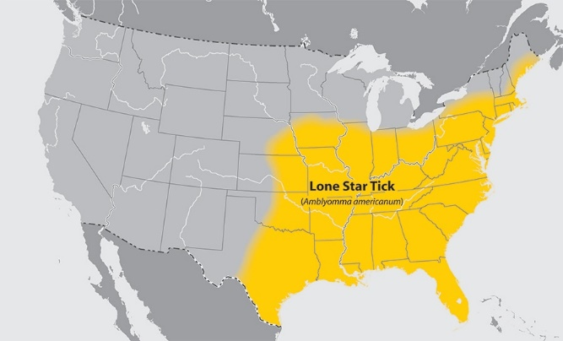

Figure 10. [Where Ticks Live | Ticks | CDC](https://www.cdc.gov/ticks/about/where-ticks-live.html)

**What are the signs and symptoms of STARI?**

STARI has a rash similar to the rash of Lyme disease. The rash of STARI is a red, expanding lesion that develops around the site of a lone star tick bite (Figure 11). The rash usually appears within 7 days of tick bite and expands to a diameter of 3 inches (8 centimeters) or more, sometimes clearing as it enlarges to produce a target or "bull's-eye" appearance.

The rash may be accompanied by fatigue, fever, headache, muscle and joint pains.

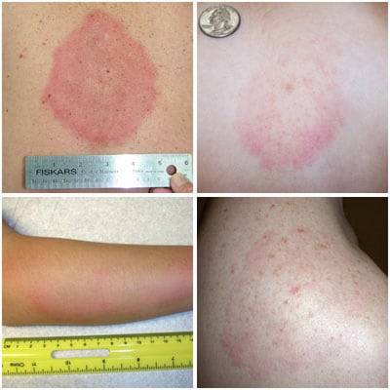

Figure 11: STARI rash

<https://www.cdc.gov/lyme/about/about-southern-tick-associated-rash-illness.html>

**How to diagnose STARI?**

STARI is diagnosed based on symptoms, geographic location, and possibility of tick bite. Because the cause of STARI is unknown, no diagnostic blood tests have been developed.

**How to treat STARI?**

It is not known whether antibiotic treatment is necessary or beneficial for patients with STARI. Nevertheless, because STARI resembles early Lyme disease, physicians will often treat patients with oral antibiotics.