Responsible Antibiotic Use in Dentistry:
A Focus on Antibiotic Stewardship
Chicago Department of Public Health Guidelines for Antibiotic Use in Dentistry

Developed by: Amy Hanson¹, PharmD, BCPS AQ-ID, Infectious Disease Pharmacist
Reviewed by: Susan Rowan², DDS, MS and Erinne Kennedy³, DMD, MPH, MMSc
¹Chicago Department of Public Health, Communicable Disease Program
²Executive Associate Dean, College of Dentistry, University of Illinois at Chicago
³Associate Dentists, Massachusetts State Employee Fund, Alliance Dental Center

Date developed: January 2020
Scope of these guidelines for antibiotic prescribing in dentistry:
Introduction
Treatment: #1) Acute oral bacterial infection (cellulitis or abscess)
#2) Acute Pericoronitis
#3) Sinus infection that presents with dental symptoms
#4) Chronic periodontal disease
Prophylaxis: #1) Prevention of surgical site infections
#2) Prevention of infective endocarditis
#3) Prevention of prosthetic joint infections

Beta-lactam Allergy Pearls:¹⁻²
- Approximately 10% of patients report a penicillin allergy, of these 80-90% will not have a positive skin test (<1 % of all patients are truly allergic). Patients may state they have a penicillin allergy, but they may be describing an adverse drug reaction or symptom of disease. Additionally, 80% of patients will “outgrow” their penicillin allergy after 10 years from previous reaction.
- Obtaining an accurate patient history is key, including asking exposure to commonly prescribed names of beta-lactam antimicrobials, and type and timing of reactions. Beta-lactams belong to an important antimicrobial class, and the inability to use them could lead to less efficacious, broader-spectrum, and/or more toxic agents being used.
- Cross-reactivity between penicillin or amoxicillin and cephalexin is low (<5%). Cephalexin can be prescribed safety in penicillin allergic patients with mild-moderate reactions (example: rash), but should be avoided with a penicillin allergy history of severe or IgE-mediated Type 1 reactions (example: shortness of breath or anaphylaxis).
- Dentists should have a low threshold to add metronidazole to cephalexin therapy in patients with a delayed response to antibiotics.
- In true history of anaphylaxis, azithromycin can be prescribed at the risk of higher resistance. Alternatively, clindamycin can be prescribed at the substantial increased risk of developing Clostridioides difficile infection (odds ratio 17-20 even after a single dose!)³

References:
¹Gonzalez-Estrada A, Radojicic C. Penicillin allergy: a practical guide for clinicians. Cleve Clin J Med. 2015;82(5):295-300.
²Blumenthal KG, Shenoy ES, Hurwitz S, Varughese CA, Hooper DC, Banerji A. Effect of a drug allergy educational program and antibiotic prescribing guideline on inpatient clinical providers’ antibiotic prescribing knowledge. J Allergy Clin Immunol. 2014;2(4):407-412..
³Vardakas KZ, Trigkidis KK, Boukouvala E, Falagas ME. Clostridium difficile infection following systemic antibiotic administration in randomized controlled trials: a systemic review and meta-analysis. Int J Antimicrob Agents 2016;48(1):1-10.

Counseling Pearls for Antibiotics Commonly Used by Dentists:

Beta-lactams (such as penicillin V potassium, amoxicillin, amoxicillin-clavulanate, and cephalexin)
- May be taken with or without food.
- Allergic reaction rarely occur (most common = mild rash)
- In general, beta-lactams are considered safe with minimal risk of side effects.
- Diarrhea can occur, but more likely after prolonged courses. Non-infectious, antibiotic-associated diarrhea is typically mild. However, if 3 or more loose stools/day for 1-2 days develops while on antibiotics, the patient should contact their primary care provider to be evaluated for antibiotic-associated Clostridioides difficile infection.
Azithromycin
- Commonly referred to as a “Z-pak”.
- Take with or without food, but food may reduce stomach upset.
- Side effects in some patients include nausea, vomiting or diarrhea.
- There is a small (<1%) risk of cardiotoxicity, and use caution in patients that are administered concomitant medications that can prolong the QTc interval.
Clindamycin
- Can take with or without food.
- Diarrhea can occur, even after a single dose. If 3 or more loose stools/day for 1-2 days develops while on antibiotics, the patient should contact their primary care provider to be evaluated for antibiotic-associated Clostridioides difficile infection.
Metronidazole
- Administer with food to minimize stomach upset.
- Metallic taste can occur for some patients.
- Do not consume alcohol with taking this medication.

Introduction:
Dentists prescribe 10% of all outpatient antibiotic prescriptions, writing more than 25.7 million prescriptions each year. General and specialty dentists are the third highest prescribers of antibiotics in all outpatient settings in the US.¹ Reports from 2017-2019 suggest that 30-85% of dental antibiotic prescriptions are “suboptimal or not indicated”.²⁻⁴ We hope a summary of available literature in these Chicago Department of Public Health (CDPH) dental prescribing guidelines will help guide more judicious use of antibiotics in your dental practice. Please use the previously distributed Dental Toolkit binder as references for additional resources and literature on dental antimicrobial stewardship.

TREATMENT REGIMENS

#1) Acute oral bacterial infection (cellulitis or abscess):^{5,6}
Management
Depending on the extent of the infection and any signs of systemic spread of infection (fever or malaise), or if the patient is immunosuppressed/otherwise medically compromised, antibiotics can be considered. Primary treatment is the surgical resolution of the dental problem; antibiotics are secondary to that process.
Treatment
When pulpotomy, pulpectomy, nonsurgical root canal treatment, incision for drainage of abscess (Definitive, Conservative Dental Treatment or DCDT) or extraction are an immediate option (same day), antibiotics are not indicated as adjunct to care in mostly all cases.
- Do not prescribe oral systemic antibiotics as adjunct to DCDT or extraction for immunocompetent adults with irreversible pulpitis, pulp necrosis, and symptomatic apical periodontitis or localized acute apical abscess unless they present with extraoral or severe intraoral swelling, and/or exhibit signs of
systemic illness.

#1) Acute oral bacterial infection treatment continued:
Evidence suggests that nonsteroidal anti-inflammatory drugs such as ibuprofen 400-600mg PO QID with meals and at bedtime plus acetaminophen 1000mg PO QID combination therapy is effective in managing dental pain.^{3, 7}

The types of bacterial organisms associated with oral infections are relatively limited, and the majority are sensitive to penicillins. Based on this, the drugs of choice are: amoxicillin 500mg PO TID for 3-7 days (or alternatively penicillin V potassium 500mg PO QID for 3-7 days). Although both amoxicillin and penicillin are first-line treatment, amoxicillin is preferred over penicillin because it is more effective against various gram-negative anaerobes and its lower incidence of gastrointestinal side effects.

As an alternative for patients with a history of penicillin allergy, but without a history of anaphylaxis, angioedema, or hives with penicillin, ampicillin, or amoxicillin, prescribe cephalexin 500mg PO QID for 3-7 days.⁸ Dentists should have a low threshold to add metronidazole to cephalexin therapy in patients with a delayed response to antibiotics. For an alternative for patients with a severe reaction to penicillin, ampicillin, or amoxicillin (anaphylaxis, angioedema, or hives) prescribe azithromycin 500mg PO x1, then 250mg for 4 days. Bacterial resistance rates for azithromycin are higher than for other antibiotics. Alternative to a beta-lactam or azithromycin is clindamycin 300mg PO QID for 3-7 days. Clindamycin substantially increases the risk of developing Clostridioides difficile infection, even after a single dose.⁹

Dentists should reevaluate patients within 3 days (for example, in-person visit or phone call). Dentists should instruct patients to discontinue antibiotics 24 after symptoms resolve, irrespective of reevaluation after 3 days. In cases that failed to respond to amoxicillin or penicillin, consider broadening antibiotic therapy to either complement first-line treatment with metronidazole 500mg PO TID for 7 days or discontinue first-line treatment and prescribe amoxicillin-clavulanate 500mg/125mg PO TID for 7 days.

Adult pain relief recommendations

Truth: Pain relief can be used in conjunction with local tooth care received from the dentist. Although opioid medications may rarely be indicated for severe, acute pain or breakthrough pain, evidence demonstrates in the vast majority of cases that non-narcotic regimens (over-the-counter acetaminophen and/or ibuprofen) are superior in relieving dental pain. Examples of these opioid medications that are less effective for dental pain, with more side effects and the potential for addiction, include: hydrocodone with acetaminophen (brand name Vicodin® or Norco®) or oxycodone with acetaminophen (brand name Percocet®).
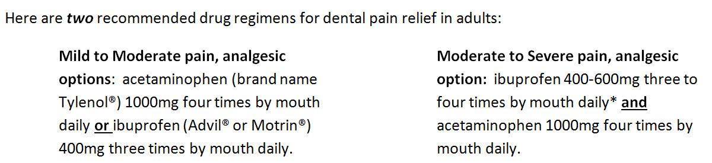
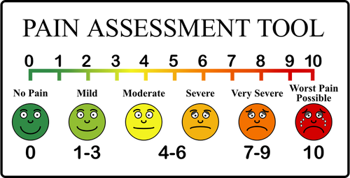
*For severe or acute conditions ibuprofen can be prescribed to a maximum of 2.4 grams daily (600mg four times a day). In some select instances, your dentist may prescribe a maximum of 3.2 grams daily (800mg four times a day). If you choose to purchase the product over the counter then the maximum dose is 1.2 grams daily (400mg three times a day). See additional information on the back side →

#2) Acute Pericoronitis¹⁰⁻¹¹
Management
Acute Pericoronitis is treated with local measures unless there is facial swelling, trismus or systemic involvement (such as fever and malaise).
Treatment
Extraction is the treatment of choice if tooth is recommended for removal. If extraction is not performed, treatment for localized tissue swelling and soreness is irrigation in the office and at home. Adjustment of opposing dentition may be considered if traumatic.
For patients with localized tissue swelling and soreness, fever < 101^{°F}, mild trismus and/or facial swelling, antibiotics are recommended.
The recommended systemic antibiotic regimen is:
- Penicillin V K 500 mg PO QID (consider a loading dose of 1,000 mg). Duration is 3-7 days.
- Alternative is clindamycin 300 mg PO TID (consider a loading dose of 600 mg). Duration is 3-7 days.
For patients with symptoms consistent with major systemic involvement (localized tissue swelling and soreness, fever >101^{°F}, severe trismus, facial swelling and/or malaise), immediate referral to an oral and maxillofacial surgeon is warranted.
#3) Sinus infection that presents with dental symptoms:⁵
Management
After a detailed dental examination and appropriate periapical radiograph(s), if there is no evidence of dental pathology, then it is unlikely the sinus pain is coming from a dental source.
Treatment
Treating sinus pain with antibiotics as a means of ruling out a dental etiology is not appropriate. Sinus infections are most often viral and will improve without use of antibiotics. The patient should be referred to their Primary Care Provider for further management.
#4) Chronic periodontal disease:⁵
Management/Treatment
Chronic periodontal disease is not amendable to antibiotic management. Management includes mechanical cleaning, and maintaining a long-term healthy oral environment is essential.

To minimize confusion, it is recommended that doses of ibuprofen and acetaminophen are taken together. Consider having a cell phone alarm act as a reminder to take medication this often. Additionally, ibuprofen and acetaminophen can be staggered and taken alternating.

Recommended regimen for combining acetaminophen + ibuprofen: preferred option
Breakfast | Lunch | Dinner | Before Bedtime
acetaminophen 1000mg | acetaminophen 1000mg | acetaminophen 1000mg | acetaminophen 1000mg
ibuprofen 400mg to 600mg | ibuprofen 400mg to 600mg | ibuprofen 400mg to 600mg | ibuprofen 400mg to 600mg
Or the alternative is to stagger the doses of acetaminophen and ibuprofen over 24 hours. If this regimen is used, ensure that ibuprofen is taken with food. Acetaminophen is taken every 4-6 hours, and ibuprofen is taken every 6-8 hours.

- Do not exceed recommended maximum doses:
- 4000mg acetaminophen in a 24 hour period
- 2400mg ibuprofen in a 24 hour period (in some instances, 3200mg ibuprofen/day)
- Before taking pain medications, always tell your dentist or pharmacist what you are already taking or normally take for pain, including any prescribed or over-the-counter remedies.
- Ibuprofen should be taken with food. Acetaminophen can be taken with or without food.

Additional prescribing precautions for ibuprofen and acetaminophen:
- Avoid ibuprofen in patients: with a hypersensitivity to aspirin or any other nonsteroidal anti-inflammatory drugs (NSAID) including those who have experienced attacks of asthma (difficulty breathing), angioedema (acute swelling allergic reaction), urticaria (hives) or rhinitis (runny or itchy nose) precipitated by aspirin or another NSAID; with active peptic ulcer disease or history of NSAID-associated ulcer disease; in the third trimester of pregnancy; with severe heart failure; taking any other NSAID painkillers.
- Use ibuprofen with caution in patients: with a history of asthma or other allergic disease, bowel problems, ulcerative colitis, Crohn’s disease or connective tissue disorders; patients with severe renal, cardiac or hepatic impairment; who are elderly; with uncontrolled hypertension; with coagulation defects or inherited bleeding disorders; in the first 6 months of pregnancy; who are breastfeeding; taking the following medicines: anticoagulants, antihypertensives, methotrexate, antidepressants, antianxiety medications, select serotonin reuptake inhibitors (SSRIs), lithium or antiplatelet agents.
- Avoid acetaminophen in patients with hypersensitivity to acetaminophen or any of the preparation excipients.
- Use acetaminophen in caution in patients with severe hepatic or renal impairment.

PROPHYLAXIS REGIMENS

#1) Prophylaxis to prevent surgical site infections:⁵
Management/Treatment
In general, literature does not support the use of antibiotics prophylactically to prevent local infections in tissues proximal/adjacent to a surgical or dental procedural site, such as a dental extraction, endodontic procedure or an implant placement. An exception may be the surgical extraction of third molars, especially in situations where there is pericoronitis. The clinician is encouraged to use their clinical judgement to evaluate the patient’s health and the extent of the procedure relative to antibiotic use in such situations. The prophylactic effect of antibiotics occurs within the first one or two doses and antibiotic use may be of detriment if continued for the next 3-7 days, especially if there are no signs of infection at the surgical site. Best practices and responsible antibiotic stewardship suggests antibiotics should be reserved to manage an infection if it occurs, rather than used in hopes of preventing the infrequent infections that may be associated with such procedures in healthy immunocompetent patients.
#2) Prophylaxis to prevent infectious endocarditis:^{5,12-14}
Background
Infectious endocarditis (IE) is more likely to result from exposure to bacteremia associated with daily activities (i.e. chewing, brushing teeth) than from a dental procedure.
Antibiotic prophylaxis (AP) may be prevented in a small number of IE cases, however the risk of antibiotic associated adverse drug reactions exceeds any expected benefit.
Management
Selection of appropriate patient need, antibiotic type and dosage is critical. The American Heart Association (AHA) 2007 guidelines recommend AP when dental treatment involves manipulation of gingival tissue, manipulation of the periapical region of teeth, or perforation of the oral mucosa, and only for highest risk patients.
Indications for AP to prevent IE prior to dental procedures include the following patients with highest cardiac risk factors for IE:

Antibiotics don’t cure a toothache!
Pediatric pain relief recommendations

Truth: Pain relief can be used in conjunction with local tooth care received from the dentist.

For regimens combining acetaminophen and ibuprofen for children, use the dosing table below:

Acetaminophen | Dose | Ibuprofen | Dose
For child 6 months – 1 year | 120mg every 4-6 hours  max 4 x per day | For child 6-11 months | 50mg 3 times daily  max daily dose in 3-4 divided doses = 30mg/kg*/day
For child 2-3 years | 180mg every 4-6 hours  max 4 x per day | For child 1-3 years | 100mg 3 times daily  max daily dose in 3-4 divided doses = 30mg/kg*/day
For child 4-5 years | 240mg every 4-6 hours  max 4 x per day | For child 4-6 years | 150mg 3 times daily  max daily dose in 3-4 divided doses = 30mg/kg*/day
For child 6-7 years | 240-250mg every 4-6 hours max 4 x per day | For child 7-9 years | 200mg 3 times daily  max daily dose in 3-4 divided doses = 30mg/kg*/day up to max 2.4 grams/day
For child 8-9 years | 360-375mg every 4-6 hours  max 4 x per day | For child 10-11 years | 300mg 3 times a day  max daily dose in 3-4 divided doses = 30mg/kg*/day up to max 2.4 grams/day
For child 10-11 years | 480-500mg every 4-6 hours  max 4 x per days | For child 12-17 years | Initially 300-400mg 3-4 times a day (up to 600 mg 4 times daily) maintenance 200-400mg 3 times daily
For child 12-15 years | 480-750mg every 4-6 hours  max 4 x per day | If you or your child exceed the recommended dose or experience any abnormal reactions, seek additional medical advice. It may be easiest to dose the acetaminophen at the same time as the ibuprofen. Ibuprofen should be taken with food. Acetaminophen may be taken with or without food.
For child 16-17 years | 500-1000mg every 4-6 hours  max 4 x per day
*kg = kilogram; to convert kg to pounds, take kg weight and multiply by 2.2

Antibiotics Won’t Cure a Toothache!
Patients need to understand that the use of antibiotics is not an acceptable treatment for almost all oral health-related problems, such as a “toothache”, and should be used only in cases of severe infection when systemic involvement is evident.
Summary of Therapeutic Antibiotic Use in Dentistry:¹
- Due to insufficient evidence supporting the use of antibiotics to treat periapical abscess, irreversible pulpitis, or symptomatic apical periodontitis, which are treated effectively through drainage by means of pulpectomy, incision, local debridement or extraction, antibiotics should not be prescribed.²⁻⁵ An exception to this would be if the patient seeks care with evidence of systemic involvement, as well as a gross, rapid, and diffuse spread of infection.^{2-3,6}
- For the treatment of pericoronitis, dentists should prescribe antibiotics only when immediate surgical removal is impossible (for example, significant trismus) and there is an acute spreading infection; otherwise, symptoms associated with pericoronitis can be improved by means of local oral irrigation measures, chlorhexidine mouthrinse, and analgesics.⁷
- Antibiotics are not indicated for the treatment of dry socket because it is not an infection. Treatment of dry socket should include site irrigation with saline or chlorhexidine, a dressing material to control the pain, analgesics, and the maintenance of proper oral hygiene.⁸
- For the treatment of sinusitis, dentists should advise the patient to seek care from their primary care physician. Because of the self-limiting, likely viral nature of this condition, antibiotics are generally not indicated.⁹
References:
¹Stein K, Farmer J, Singhal S, Marra F, Sutherland S, Quinonez C. The use and misuse of antibiotics in dentistry: a scoping review. JADA. 2018;149(10):869-884 e5.
²Lockhart PB, Tampi MP, Abt E et al. Evidence-based clinical practice guideline on antibiotic use for the urgent management of pulpal- and periapical-related dental pain and intraoral swelling. JADA. 2019:150(11);906-921.e12.
³American Association of Endodontists. AAE guidance on the use of systemic antibiotics in endodontics. Available at: https://www.aae.org/specialty/wp-content/uploads/sites/2/2017/06/aae_systemic-antibiotics.pdf. Accessed January 8, 2020.
⁴Agnihotry A, Fedorowicz A, van Zuuren EJ, et al. Antibiotic use for irreversible pulpitis. Cochrane Database Syst Dev. 2016;2:CD004969.
⁵Cope A, Francis N, Wood F, et al. Systemic antibiotics for symptomatic apical peridontitis and acute apical abscess in adults. Cochrane Database Syst Rev. 2014;6:CD010136.
⁶Palmer NA. Revisiting the role of dentists in prescribing antibiotics. Dent Update. 2003;30(10):570-574.
⁷Renton T, Wilson NHF. Problems with erupting wisdom teeth: signs, symptoms and management. Br J Gen Pract. 2016;66:e606-3608.
⁸Chemaly D. How do I manage a patient with dry socket? J Can Dent Assoc. 2013;79:d54.
⁹Scottish Dental Clinical Effectiveness Programme. Drug Prescribing in Dentistry: Dental Clinical Guidance. 3rd ed. Dundee, United Kingdom: Scottish Dental Clinical Effectiveness Programme: 2016.

#2) Prophylaxis to prevent IE management continued:
- Prosthetic cardiac valves or materials for valve repair
- Prior infective endocarditis
- Congenital heart disease (CDH) such as unrepaired cyanotic CHD (including palliative shunts and conduits); completely repaired defects with prosthetics during the first 6 months after the procedure; repaired CHD with residual defects at or near the site of a prosthetic patch or device
- Cardiac transplant recipients with cardiac valvulopathy
In 2017 the AHA/American College of Cardiology expanded this AP recommendation to include: patients with transcatheter prosthetic valves and patients with prosthetic material used for valve repair such as annuloplasty rings and chords. The addition was based on observational studies for increased risk of IE.¹⁵
Treatment
Regimens for IE prophylaxis include:
- Amoxicillin 2Gm PO x1 30-60 minutes prior to the procedure, and ampicillin 2Gm IM or IV x1 30-60 minutes preop if unable to take oral medications.
- Patients with a penicillin allergy (non-severe reactions including rash) due to side-chain dissimilarity can safely be prescribed cephalexin 2Gm PO x1 30-60 minutes preop, and this is preferred over the alternative classes of antibiotics (macrolides and clindamycin) to optimize antibiotic coverage (and less risk of antibiotic resistance) in balance with a safer antibiotic side effect profile.
- Cefazolin has a unique R-1 side chain and is also associated with low to no risk of cross-reactivity with penicillins in patients unable to take oral medication (cefazolin 1Gm IM or IV 30-60 minute preop).
- In the case of a severe (history of anaphylaxis, angioedema, or hives) penicillin allergy, administer azithromycin 500mg PO x1 30-60 minutes preop.
- Alternatively, consider clindamycin 600mg (PO, IM or IV) 30-60 min preop. (or clarithromycin 500mg PO x1 30-60 min preop).

#3) Prophylaxis to prevent prosthetic joint infections:^{5, 13}
Management
The best available evidence to date shows that dental procedures are not associated with a prosthetic joint infection (PJI) in the immunocompetent patient.¹⁶⁻¹⁸ In a case-control study of 339 patients with PJIs, Berbari et al¹⁹ matched cases with 339 control patients without infection and assessed dental procedure as “exposure”. In the immunocompetent patient, there was no statistical association between high-risk procedures (i.e. extractions, dental abscess treatment) without AP and PJI at six months or two years. The American Association of Orthopedic Surgeons’²⁰ recommends prophylaxis for severely immunocompromised patients in the following categories: Stage 3 AIDS, patients undergoing immunosuppressive chemotherapy, immunosuppressed patients with solid organ transplants, and during certain stages of bone marrow transplantation.
Treatment
If this practice is being recommended by an orthopedic surgeon and your clinician-to-clinician discussion of risk vs benefit is unable to persuade the surgeon and/or patient away from prophylaxis and the decision is made collectively to prescribe, the same regimen is followed as that of infective endocarditis prophylaxis.

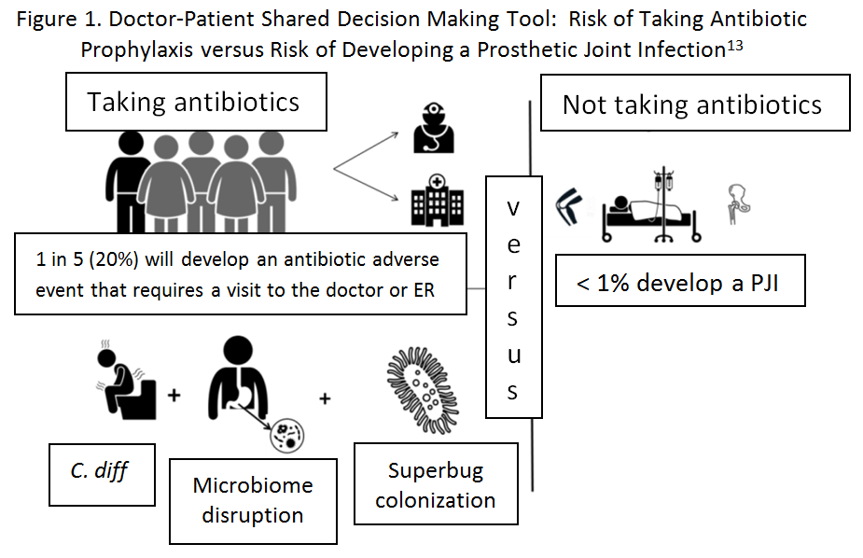

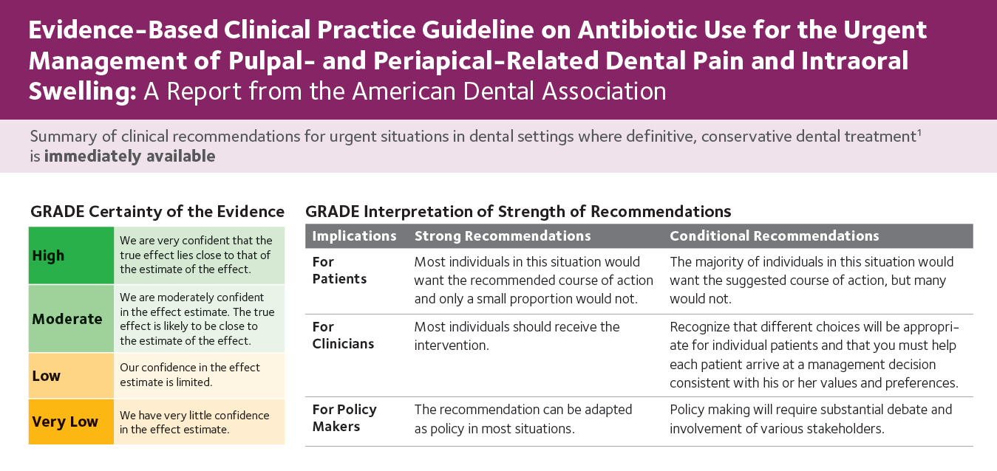
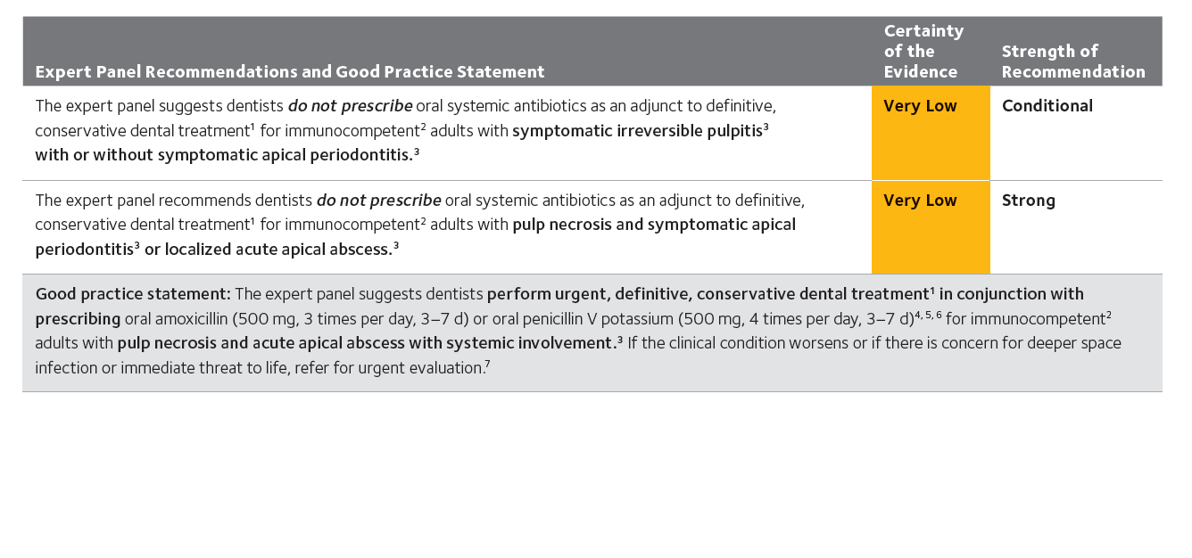
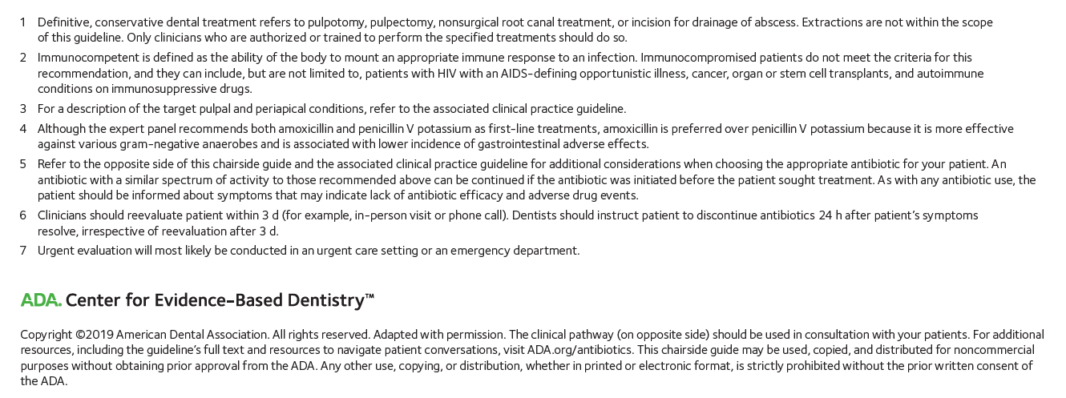

References:
¹Derkin MJ, Hseuh K, Sallah YH et al. An evaluation of dental antibiotic prescribing practices in the US. JADA. 2017;148(12):878-886 e1.
²Gross AE, Hannah D, Rowan SA, Bleasdale SC, Suda KJ. Successful implementation of an antibiotic stewardship program in an academic dental practice. OFID. 2019;6(3):1-6.
³Suda KJ, Henschel H, Patel U et al. Use of antibiotic prophylaxis for tooth extractions, dental implants, and periodontal surgical procedures, OFID. 2018;5(1):1-5.
⁴Loffler C, Nohmer F. The effect of interventions aiming to optimize the prescription of antibiotics in dental care: a systemic review. PloS One. 2017;12(11):1-23.
⁵Siegel JD and Epson E. Antibiotic Prescribing and Stewardship in Dentistry: A Public Health Perspective. Journal of the California Dental Association. 2018;(46):755-765.
⁶Lockhart PB, Tampi MP, Abt E et al. Evidence-based clinical practice guideline on antibiotic use for the urgent management of pulpal- and periapical-related dental pain and intraoral swelling. JADA. 2019:150(11);906-921.e12.
⁷Moore PA, Ziegler KM, Lipman RD, Aminoshariae A, Carrasco-Labra A, Mariotti A. Benefits and harms associated with analgesic medications used in the management of acute dental pain: an overview of systemic reviews. JADA. 2018;149(4):256-265 e3.
⁸Blumenthal KG, Peter JG, Trubiano JA et al. Antibiotic Allergy. Lancet. 2019;393(10167):187-198.
⁹Gross AE et al. “SHEA Featured Oral Abstract: Serious Antibiotic-Related Adverse Effects Following Unnecessary Dental Prophylaxis in the United States” ID Week 2019; Abstract 1895.
¹⁰Hupp J, Elis E and Tucker M. Contemporary oral and maxillofacial survey, 2019. 7th ed. Philadelphia: Elsevier, p. 163.
Stein K, Farmer J, Singhal S, Marra F, Sutherland S, Quinonez C. The use and misuse of antibiotics in dentistry: a scoping review. JADA. 2018;149(10):869-884 e5.
¹¹Blakey GH, White RP, Offenbacher S et al. Clinical/biological outcomes of treatment for pericoronitis. Journal of Oral and Maxillofacial Survey 1996, 54(10), 1150-1160.
¹²Wilson W, Taubert KA, Gewitz M et al. Prevention of infective endocarditis: Guidelines from the American Health Association. JADA 2008 Jan;139 Suppl:3S-24S.
¹³Goff DA, Mangino JE, Glassman AH et al. Review of guidelines for dental antibiotic prophylaxis for prevention of endocarditis and prosthetic joint infections and need for dental stewardship. CID 2019; doi: 10.1093/cid/ciz1118. [Epub ahead of print]
¹⁴Chen TT, Yeh YC, Chien KL et al. Risk of infective endocarditis after dental treatments. Circulation 2018; 138(4):356-63.
¹⁵Nishimura RA, Otto CM, Bonow RO et al. 2017 AHA/ACC Focused update of the 2014 AHA/ACC guideline for the management of patients with valvular heart disease: a report of the ACC/AHA task force on clinical practice guidelines. J Am Coll Cardiol 2017;70(2):252-89.
¹⁶Sollecito TP, Abt E, Lockhart PB et al. The use of prophylactic antibiotics prior to dental procedures in patients with prosthetic joints: Evidence-based clinical practice guideline for dental practitioners – a report of the American Dental Association Council on Scientific Affairs. JADA 2015;146(1):11-6 e8.
¹⁷Berbari EF, Osmon DR, Carr A et al. Dental procedures as risk factors for prosthetic hip or knee infection: a hospital-based prospective case-control study. CID 2010; 50(1):8-16.
¹⁸Skaar DD, O’Connor H, Hodges JS et al. Dental procedures and subsequent prosthetic joint infections: findings from the medicare current beneficiary survey.JADA 2011;142(12):1343-51.
¹⁹Swan J, Dowsey M, Babazadeh S et al. Significance of sentinel infective events in haematogenous prosthetic knee infections. ANZ J Surg 2011;81(1-2):40-5.
²⁰American Association of Orthopedic Surgeons. Appropriate Use Criteria for the Management of Patient with Orthopaedic Implants Undergoing Dental Procedures.
Available at: https://www.aaos.org/uploadedFiles/PreProduction/Quality/AUCs_and_Performance _Measures/appropriate_use/auc-patients-with-orthopaedic-implants-dental-procedures.pdf.

