Reminder Hands are the number one way germs are transmitted.  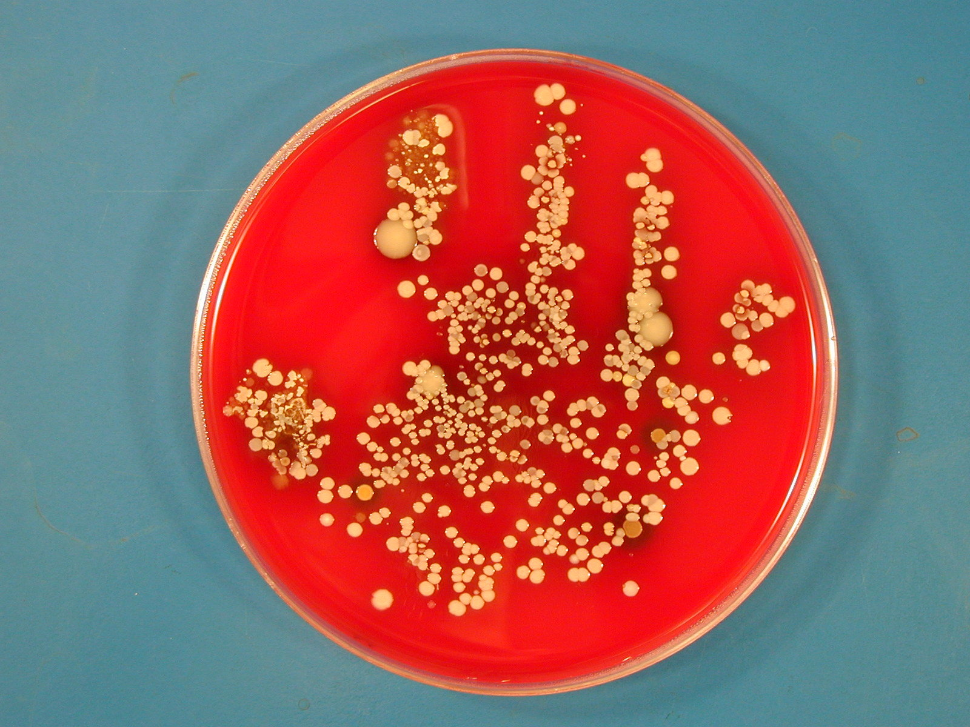 | Reminder Hands are the number one way germs are transmitted.
Reminder Hands are the number one way germs are transmitted. | Reminder Hands are the number one way germs are transmitted.
Reminder Hands are the number one way germs are transmitted. | Reminder Hands are the number one way germs are transmitted.
Reminder Hands are the number one way germs are transmitted. | Reminder Hands are the number one way germs are transmitted.
Reminder Hands are the number one way germs are transmitted. | Reminder Hands are the number one way germs are transmitted.
Clean your hands:  - Upon entering each room  - Upon exiting each room  - Between each resident  - Before and after the use of gloves | Clean your hands:  - Upon entering each room  - Upon exiting each room  - Between each resident  - Before and after the use of gloves
Clean your hands:  - Upon entering each room  - Upon exiting each room  - Between each resident  - Before and after the use of gloves | Clean your hands:  - Upon entering each room  - Upon exiting each room  - Between each resident  - Before and after the use of gloves
Clean your hands:  - Upon entering each room  - Upon exiting each room  - Between each resident  - Before and after the use of gloves | Clean your hands:  - Upon entering each room  - Upon exiting each room  - Between each resident  - Before and after the use of gloves
Clean your hands:  - Upon entering each room  - Upon exiting each room  - Between each resident  - Before and after the use of gloves | Clean your hands:  - Upon entering each room  - Upon exiting each room  - Between each resident  - Before and after the use of gloves
Clean your hands:  - Upon entering each room  - Upon exiting each room  - Between each resident  - Before and after the use of gloves | Clean your hands:  - Upon entering each room  - Upon exiting each room  - Between each resident  - Before and after the use of gloves

