Antibiotics don’t cure a toothache!
Adult pain relief recommendations

Truth: Pain relief can be used in conjunction with local tooth care received from the dentist. Although opioid medications may rarely be indicated for severe, acute pain or breakthrough pain, evidence demonstrates in the vast majority of cases that non-narcotic regimens (over-the-counter acetaminophen and/or ibuprofen) are superior in relieving dental pain. Examples of these opioid medications that are less effective for dental pain, with more side effects and the potential for addiction, include: hydrocodone with acetaminophen (brand name Vicodin® or Norco®) or oxycodone with acetaminophen (brand name Percocet®).
Here are two recommended drug regimens for dental pain relief in adults:

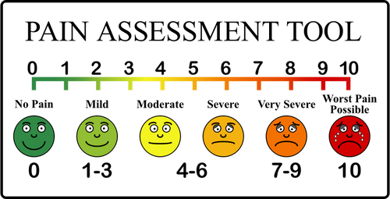
Mild to Moderate pain, analgesic options: acetaminophen (brand name Tylenol®) 1000mg four times by mouth daily or ibuprofen (Advil® or Motrin®) 400mg three times by mouth daily.
Moderate to Severe pain, analgesic option: ibuprofen 400-600mg three to four times by mouth daily* and acetaminophen 1000mg four times by mouth daily.

*For severe or acute conditions ibuprofen can be prescribed to a maximum of 2.4 grams daily (600mg four times a day). In some select instances, your dentist may prescribe a maximum of 3.2 grams daily (800mg four times a day). If you choose to purchase the product over the counter then the maximum dose is 1.2 grams daily (400mg three times a day). See additional information on the back side →

To minimize confusion, it is recommended that doses of ibuprofen and acetaminophen are taken together. Consider having a cell phone alarm act as a reminder to take medication this often. Additionally, ibuprofen and acetaminophen can be staggered and taken alternating.
Recommended regimens for combining acetaminophen and ibuprofen: preferred option
Breakfast | Lunch | Dinner | Before Bedtime
acetaminophen 1000mg | acetaminophen 1000mg | acetaminophen 1000mg | acetaminophen 1000mg
ibuprofen 400mg to 600mg | ibuprofen 400mg to 600mg | ibuprofen 400mg to 600mg | ibuprofen 400mg to 600mg
Or the alternative is to stagger the doses of acetaminophen and ibuprofen over 24 hours. If this regimen is used, ensure that ibuprofen is taken with food. Acetaminophen is taken every 4-6 hours, and ibuprofen is taken every 6-8 hours.

- Do not exceed recommended maximum doses:
- 4000mg acetaminophen in a 24 hour period
- 2400mg ibuprofen in a 24 hour period (in some instances, 3200mg ibuprofen/day)
- Before taking pain medications, always tell your dentist or pharmacist what you are already taking or normally take for pain, including any prescribed or over-the-counter remedies.
- Ibuprofen should be taken with food. Acetaminophen can be taken with or without food.

Additional prescribing precautions for ibuprofen and acetaminophen:
- Avoid ibuprofen in patients: with a hypersensitivity to aspirin or any other nonsteroidal anti-inflammatory drugs (NSAID) including those who have experienced attacks of asthma (difficulty breathing), angioedema (acute swelling allergic reaction), urticaria (hives) or rhinitis (runny or itchy nose) precipitated by aspirin or another NSAID; with active peptic ulcer disease or history of NSAID-associated ulcer disease; in the third trimester of pregnancy; with severe heart failure; taking any other NSAID painkillers.
- Use ibuprofen with caution in patients: with a history of asthma or other allergic disease, bowel problems, ulcerative colitis, Crohn’s disease or connective tissue disorders; patients with severe renal, cardiac or hepatic impairment; who are elderly; with uncontrolled hypertension; with coagulation defects or inherited bleeding disorders; in the first 6 months of pregnancy; who are breastfeeding; taking the following medicines: anticoagulants, antihypertensives, methotrexate, antidepressants, antianxiety medications, select serotonin reuptake inhibitors (SSRIs), lithium or antiplatelet agents.
- Avoid acetaminophen in patients with hypersensitivity to acetaminophen or any of the preparation excipients.
- Use acetaminophen in caution in patients with severe hepatic or renal impairment.

